**OUTPUT Week 1 Data Structures and Algorithms**

Q1: E-Commerce Platform

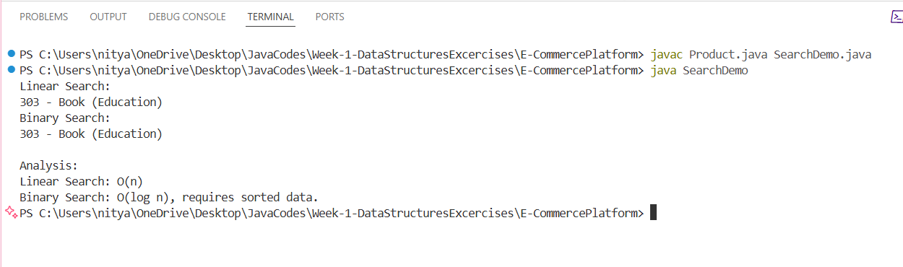

Q2: Financial Forecast